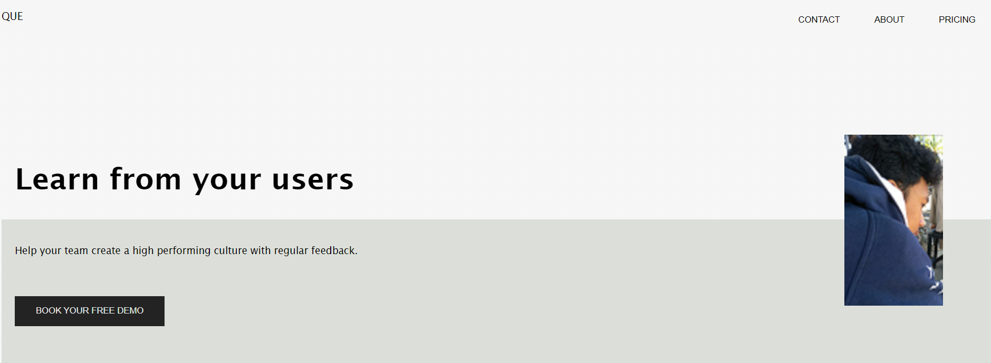

Referensi : <https://cdn.dribbble.com/users/6234/screenshots/16675450/media/b2bf32d86d501264f5d91ba5217742af.png>